Social Media:

A usability study between
the communication websites,
Bluesky and X (formerly Twitter).



By Todd Carter
June 10th, 2025
Table of Contents
Introduction 3
Methodology 3
Test environment: 3
Tasks: 3
Evaluating Criteria: 4
Results 5
Task 1: Sign up for an account. 5
Task 2: Navigate to the Home Page. 7
Task 3: Create a new post. 8
Task 4: Editing a profile. 10
Task 5: Find and follow another user. 12
Task 6: Block another user. 13
Task 7: Requesting technical assistance. 15
Task 8: Change the language settings. 16
Task 9: Change the privacy settings. 18
Task 10: Delete an account. 19
Conclusion 21
Bibliography 22
Appendix 23

Introduction

The social media websites Bluesky and Twitter are applications that allow users to post relatively short messages in a public forum. Both websites are designed to appeal to wide audiences and provide a sleek, easy to understand interface. Each provide a simple and functional front-end experience for users to participate in conversation and discussion by way of their posted messages and responses from other users.

This report focuses on users who are new to both websites that are seeking to know the technical differences in their functionality. This will provide comparison information about the common functionalities of both sites so as to help the reader make an informed decision.

Methodology

Test environment:

Testing was performed on a Lenovo laptop with an I5 Intel processor. The browser used was Mozilla Firefox which was operating with the uBlock Origins advertisement and script blocking add-on. Each task was performed after typing in the name of the website into the task bar of a newly opened browser window.

Tasks:

- Sign up for an account.
- Navigate to the home page.
- Create a new post.
- Edit your profile.
- Find and follow another user.
- Block another user.
- Request technical assistance.
- Locate the Terms of Service and Privacy Policy.
- Change the privacy settings.
- Delete an account.

Evaluating Criteria:

After completion of each task, an evaluation will be made using the following criteria:

Effective: The task was possible for a standard user to complete.

Efficient: The task was able to be completed in a reasonable time frame.

Engaging: The task was satisfying and easily completed.

Error Tolerant: There were few to none errors that could be made easily along the way.

Easy to Learn: The interface was intuitive and easy to learn, letting the tasks be completed without outside assistance.

These five criteria will be measured on a six-point Likert scale to rate the agreement level of the author. As this is a comparison between two similar products, the six-point scale was chosen over the five-point scale, as a midpoint or “average” score would seem to indicate unspoken comparison with products outside this project.

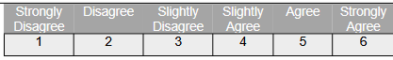

Results

Task 1: Sign up for an account.

X (formerly Twitter):

Accessing X directed a user to the account creation and/or login screen, as shown in Figure 1. Creating a new account requested a user enter either a phone number or an email address in addition to their birthday. Afterwards were no less than ten captcha tests of surprising difficulty. After completing the captcha, no email was ever sent or received, which forced the use of a phone with SMS texting to complete account creation.

  Figure 1 First page of X | 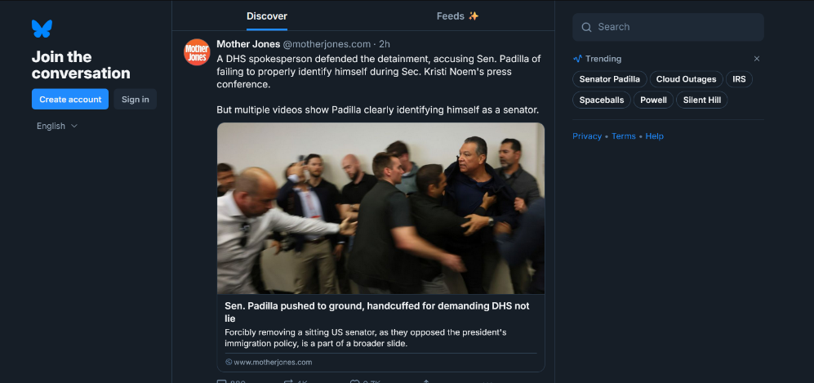  Figure 2 First page of Bluesky
Using a phone triggered the long captcha again before being texted an SMS authentication. Next came prompting to enter a profile picture, a username, a password, and a list of interests. Interests could not be skipped, so “Gaming” was selected from the options. Accounts to follow were presented next and also could not be skipped, so “Nintendo of America” was chosen.

Completing the account creation redirected to a sign-in screen, finishing the test.

Bluesky:

Accessing Bluesky brings the user to an active media stream where they can view curated posts meant for the public. This page had a small but noticeable button that started the account creation process, as seen in Figure 2.

Starting to create and account began with entering an email address, password, birth date, and username, before completing a relatively mild captcha. Next were requests to upload a profile picture, followed by a list of suggested interests that would be used in the feed. Unlike with X, the list of interests was not mandatory and could be skipped, and there was no list of possible accounts to follow.

Finishing account creation resulted in an automatic log-in and redirect back to the main page. There was no email verification at this stage.

Findings for Task 1:  Overall, signing up for a new account was much easier on Bluesky. Extra attempts at authentication and no email ever being sent was a large drawback for X in comparison.  On the 6-point Likert scale, Bluesky scored a 27 for Task 1, as compared to X, which scored a 13. | Figure 3 Results for Task 1.

Task 2: Navigate to the Home Page.

X (formerly Twitter):

Finding the home page of any website is important for accessing public information for all users. Starting from a closed window, accessing the home page of X required logging in with verified credentials. Once logged in, several panels that each displayed different pieces of information and navigation for the website were presented, including a left-hand panel with a list of useful links. After navigating around to other parts of the website, the home page could still be reached with the “Home” link.
Bluesky:

Similarly to X, Bluesky presented the home page on logging in from a closed window. Using the “Home” button allowed the return to the home page from nearly any other page on the site itself. In this task, the two websites were comparable, though Bluesky retained log in credentials, making it easier to initially access the home page.

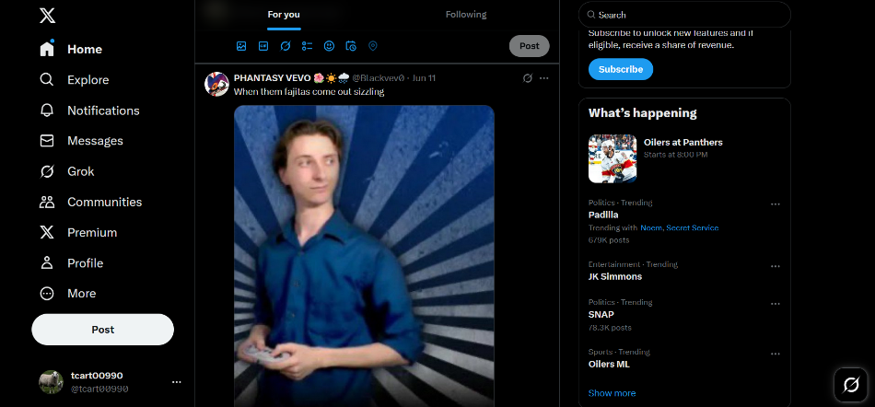  Figure 4 Home page of X | 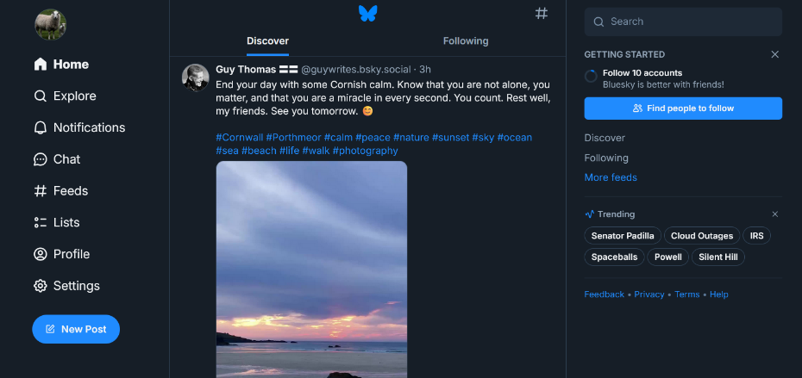  Figure 5 Home page of Bluesky

Findings for Task 2:  The two media websites were comparable in this task, except for Bluesky having more generous log in retention than X.  On the 6-point Likert scale, Bluesky scored a 30 and X scored a slightly lower 28. | Figure 6 Results for Task 2.

Task 3: Create a new post.

X (formerly Twitter):

The most direct method of creating a new post on X first required logging in and accessing the home page. At the top of the home page was an entry field with the faded words “What’s Happening?” that could be used to create a new post. Beneath this entry field were controls for settings for who could reply, inserting images, gifs, and emojis, including a poll for people to vote in, using the built-in AI “Grok” for editing, and enabling scheduling for automatic posting. These appeared as buttons on the top and bottom of the popup, as seen in Figure 7.

Posting the message resulted in a popup window advertising a subscription to unlock more content, though also a popup that of success.

Bluesky:

Making a new post on Bluesky required going to the front page and using the “New Post” button on the bottom left side of the screen. However, when attempting to make a post, a popup occurred to verify the email address, something that was not done during account creation.

The popup provides the ability to add an image, a video, a gif, or an emoji and control who can reply, similarly to X, though does not have the option to ask an AI for assistance nor include a poll or schedule when the post should go out. There is also no way to save a draft of the message. Bluesky offers instead a button to add a second post at the same time or the ability to change the language of the post. These options appear as buttons at the bottom of the popup, as seen in Figure 8.

Posting included a small popup that informed of success.

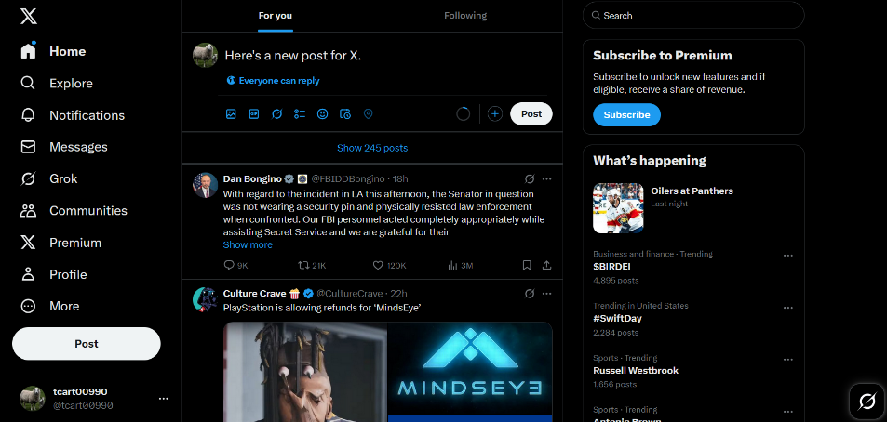  Figure 7 Posting on X (formerly Twitter) | 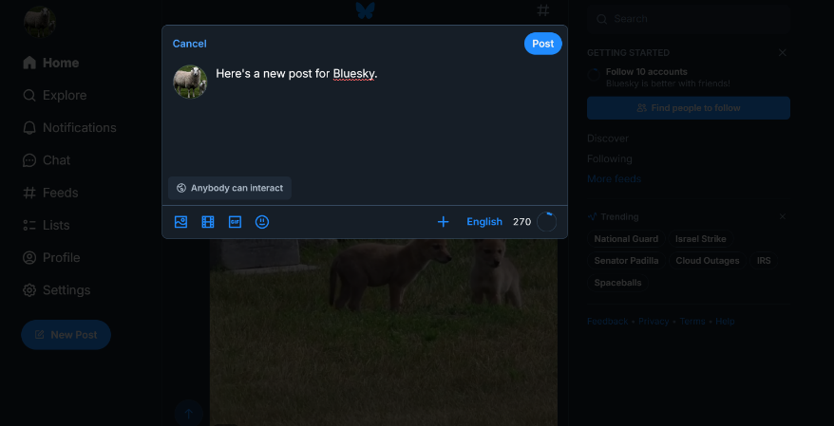  Figure 8 Posting on Bluesky

Findings for Task 3:  Having an AI assistant and a more complex posting system meant Bluesky was overall easier to create new posts, though security issues may be raised since Bluesky did not verify the email initially. Though X displayed a popup suggesting a subscription which counted against it, it had more engaging content overall.  On creating a new post, Bluesky scored a 24 on the 6-point Likert scale, and X scored a 21. | Figure 9 Results for Task 3

Task 4: Editing a profile.

X (formerly Twitter):

Editing a profile on X meant using the “Profile” button on the left side of the home page, then the “Edit profile” button next. The popup that opened to enter the new profile information included profile picture, name, biography, location, and website. Scrolling downward on the popup presented additional options for changing the user’s birthday, creating an expanded bio, and switching to an enhanced version of the website, options seen in Figure 10.

Bluesky:

Editing a profile on Bluesky presented a simpler process. The only fields available for altering were profile picture, display name, and description.

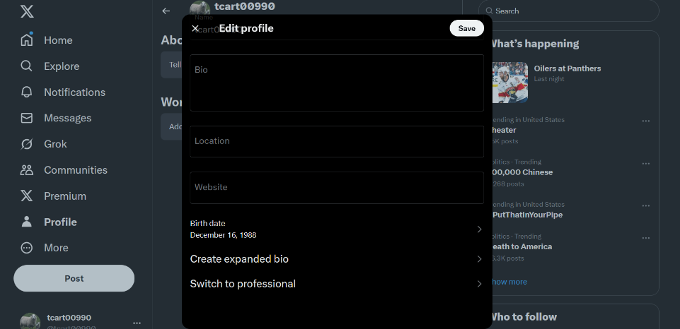  Figure 10 Editing profile in X | 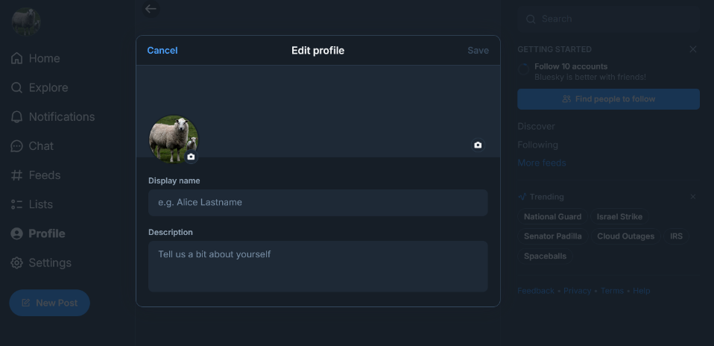  Figure 11 Editing profile in Bluesky

Findings for Task 4:  Both websites had different benefits to the systems they have in place for changing profile information, with X proving to be much more complex than Bluesky. This made X more engaging, though not as easy to use or efficient. Bluesky was more efficient, but with less content to engage a user.  On the six-point Likert scale, X scored a 24, while Bluesky scored a slightly lower 23. | Figure 12 Findings for Task 4.

Task 5: Find and follow another user.

X (formerly Twitter):

The system for finding a specific user on X was not immediately obvious. The search bar on the top right of the screen proved to be required to find specific users other than those suggested by the website itself. Searching for “Mark Hamill” produced a list of postings by the “Mark Hamill” account and of other postings that included references to him. These postings included a “Follow” button for the posting as seen in Figure 13, completing this task after following the “Mark Hamill” account.

Bluesky:

The home page of Bluesky provides an option to find other people to follow starting with a noticeable blue button. Using this produces a popup that includes a search bar above a list of accounts suggested for following. Searching for “Mark Hamill” changed the list to include the “Mark Hamill” account at the top. An unlabeled plus sign was the button for then following the account, as seen in Figure 14. This system is for the first ten follows and may not remain for beyond ten.

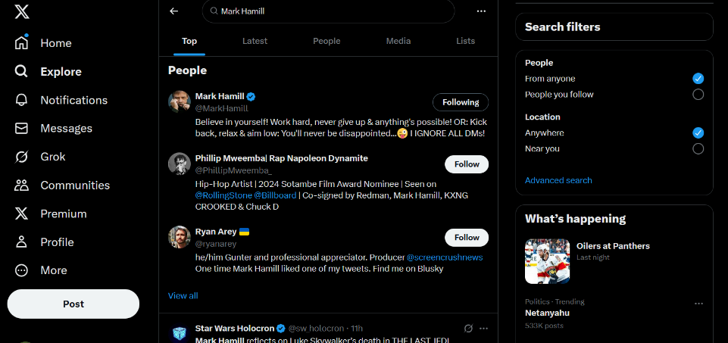  Figure 13 Follow a user on X. | 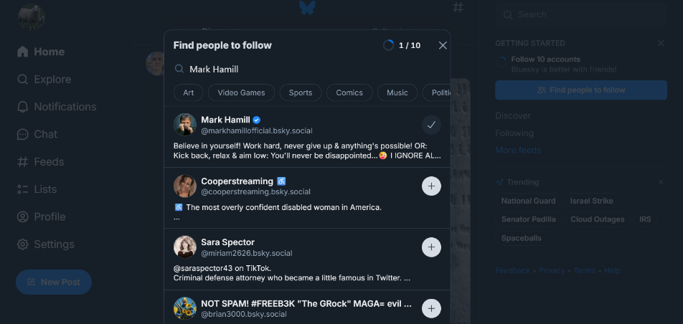  Figure 14 Follow a user on Bluesky.

Findings for Task 5:  Finding and following users on X was not as immediately obvious as on Bluesky, leading to lost efficiency. X had less engagement on encouraging following as well, with Bluesky guiding new users to follow at least ten people as if playing a game. However, the system to follow users was easier to learn and more reliable on X than on Bluesky, generally requiring less steps to follow another user.  Bluesky scored a 21 on the Likert scale, while X scored a 17. | Figure 15 Findings for Task 5.

Task 6: Block another user.

To test blocking a user, the home page was refreshed and the first user in the feed was chosen to be blocked.

X (formerly Twitter):

Blocking a user on X requires selecting the “three dot” button that appears on each posting. This is a standardized symbol that indicates further settings. Using it opens a menu that includes an option to block the account, as seen in Figure 16. Selecting the block option presented another popup that warned about the effects of blocking another user to confirm the choice. After blocking, the posts from that account disappeared from the home page feed.

Bluesky:

Blocking a user on Bluesky requires first accessing their profile, which is done by selecting their name from a post on the feed. Once viewing their profile, there was also a “three dot” button that opens a dropdown with the block option shown in Figure 17. There was also a popup warning about the effects of blocking, before the account’s posts became hidden from the home page and from their profile. This included blurring out their profile picture.

  Figure 16 Block a user on X. | 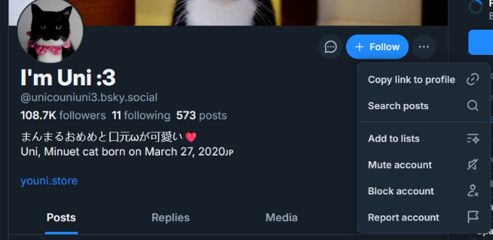  Figure 17 Block a user on Bluesky.

Findings for Task 6:  Though blocking users is relatively easy on both platforms, Bluesky required an extra step in blocking a user and being required to first visit their profile. This caused lost efficiency and lowered engagement, though the websites were comparable otherwise.  On the Likert scale, X scored a 25, while Bluesky scored a 20. | Figure 18 Findings for Task 6.

Task 7: Requesting technical assistance.

X (formerly Twitter):

Support options were not immediately obvious on X and required clicking through the menus under “Settings and Privacy” to locate a link to the Help Center. At the Help Center was a list of useful FAQs and other information. The “Contact Us” button in the Help Center was used to attempt to find a way to produce a help ticket or reach out. At the bottom of the “Contact Us” Help Center page was an X account for support questions and requests.

The @Support account is no longer active and all of its posts are hidden, as seen in Figure 19.

Bluesky:

The Settings menu on the home page led to a menu including a “Help” option. Following this led to the Bluesky Help Center, which had a link labeled “Submit a request” at the top of the page. Following this link led to a form to submit a ticket to their technical support, including fields for device, email, and other relevant information, shown in Figure 20.

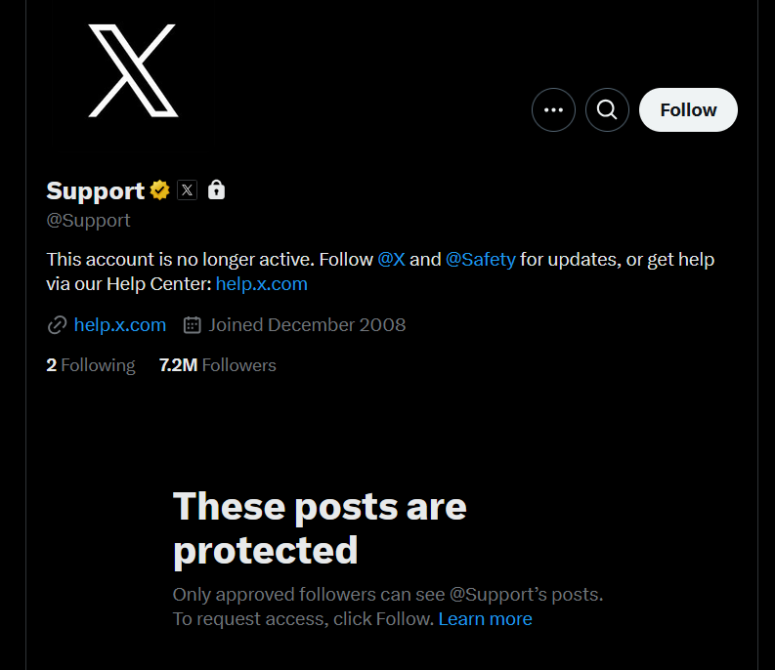  Figure 19 X support request. | 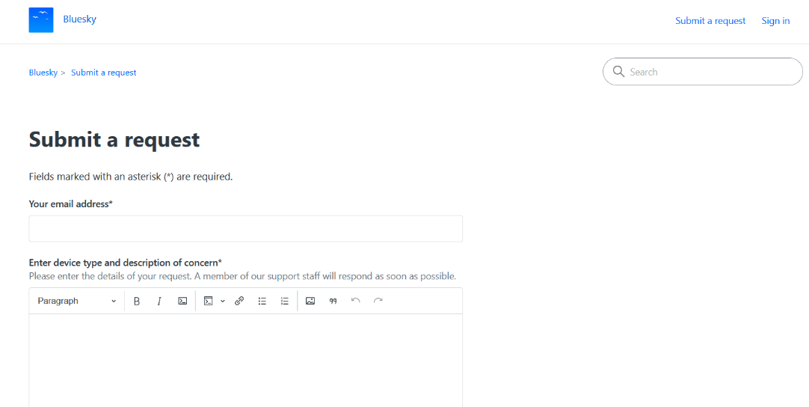  Figure 20 Bluesky support request.

Findings for Task 7:  Being unable to find interactive support that wasn’t AI driven on X was a major drawback, though this was possibly due to not having a real problem to pursue.  Bluesky offered a much more engaging and efficient solution, though at the much greater risk of user error. Having a way to quickly submit a problem when it’s discovered is a positive feature, especially for new users.  The difference in quality of technical support is considerable, with Bluesky scoring a 26 and X scoring a 6. | Figure 21 Findings for Task 7.

Task 8: Change the language settings.

X (formerly Twitter):

Altering language settings is an important feature for users around the world. On X, changing the display language required clicking through several menus within the “Settings” panel in order to find the Languages menu, shown in Figure 22. In this menu were options to change the display language, select additional languages, and to use X’s algorithms to guess at additional languages.

Bluesky:

Altering the language settings on Bluesky took three clicks when starting from the home page. The Languages menu, as shown in Figure 23, allowed controlling the language used for the user interface, the language translation in the feed, and languages for suggested content on your feed.

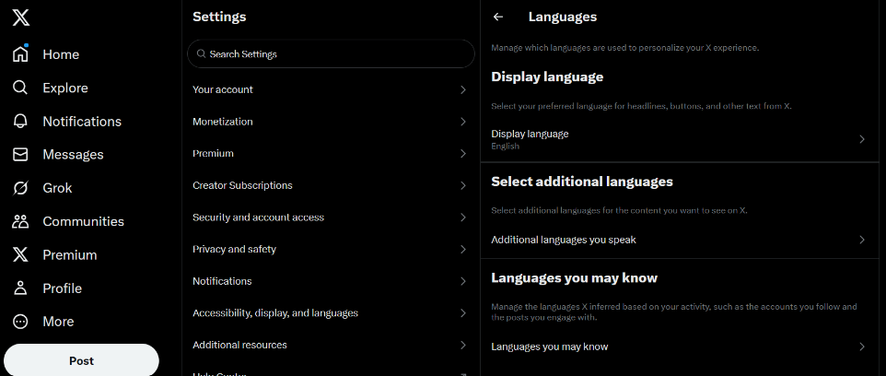  Figure 22 X language menu. | 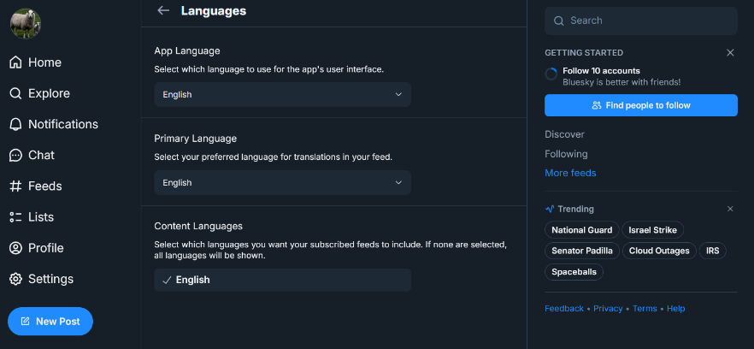  Figure 23 Bluesky language menu.

Findings for Task 8:  Overall, Bluesky offered an easier and faster way to change the language settings, as well as simpler and more intuitive options.  However, X offered an in-depth look at the user’s languages and their language options, providing better user engagement.  Both were easy to learn, with self-explanatory descriptions presented on screen.  Bluesky scored an overall 25, and X scored an 18. | Figure 24 Findings for Task 8.

Task 9: Change the privacy settings.

X (formerly Twitter):

Altering the privacy settings on X required first clicking through several menus under “Settings.” The menu was called “Privacy and Safety” and allowed changing the various content moderation policies of the main feed. There was little issue locating these menus through their descriptive names. This setting menu enabled changing which other users could see and interact with public posts from a logged-in account, shown in Figure 25.

Bluesky:

Finding the privacy settings on Bluesky first led to opening the a different menu labeled “Privacy and Security” that only allowed for altering the password, logged-out visibility, and two-factor authentication. Privacy settings in regards to postings and interactions with other users were found under the “Moderation” menu instead, which had an interface that used buttons that could be easily selected and reset, as shown in Figure 26.

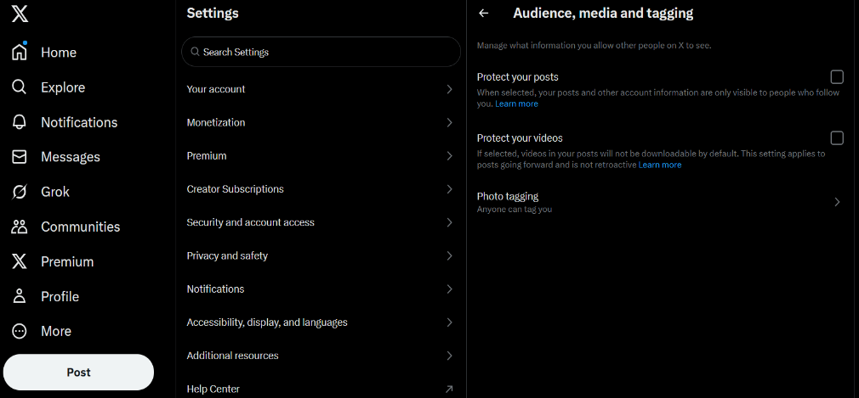  Figure 25 X privacy settings for reply moderation. | 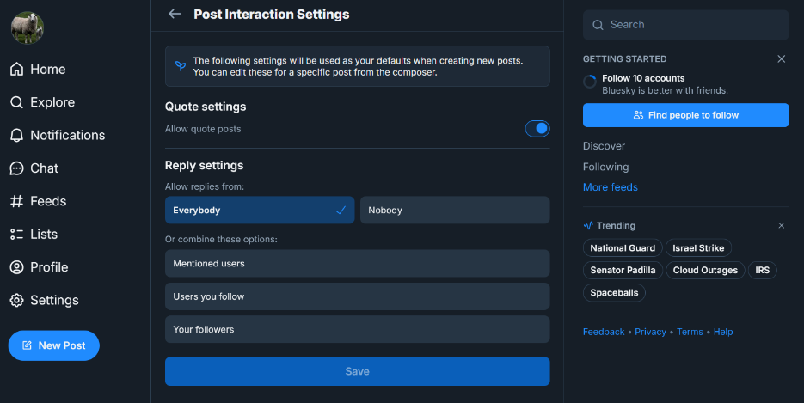  Figure 26 Bluesky privacy settings for reply moderation.

Findings for Task 9:  The privacy settings for both platforms were reasonable to find, though easier for X than Bluesky due to differences in labeling schemes. Following menus labeled “Privacy” is more intuitive than using synonyms, but the actual menus themselves were much better on Bluesky than on X.  Bluesky scored a 25 on the Likert scale, while X scored an 18. | Figure 27 Change the Privacy Settings

Task 10: Delete an account.

X (formerly Twitter):

Deleting an X account required stepping through the “Settings” menu and navigating to the “Your Account” menu. There was the option to deactivate the account, which is technically not the same as outright deletion. Deactivating the account only disables the information and posts until the account is deleted after thirty days of inactivity, which is explained in the final menu shown in Figure 28.

Deactivation required inputting the password, before being redirected to the now deactivated account.

Bluesky:

Two clicks into the “Settings” menu lands on the “Account” page, shown in Figure 29, where a user can both deactivate their account and delete it outright. Selecting deactivation showed that it is a different process than X that will not delete the account, so the deletion option was chosen instead for this test.

Account deletion required an email confirmation and the password to be inputted. After deletion was complete, the page was redirected to a “Create Account” page.

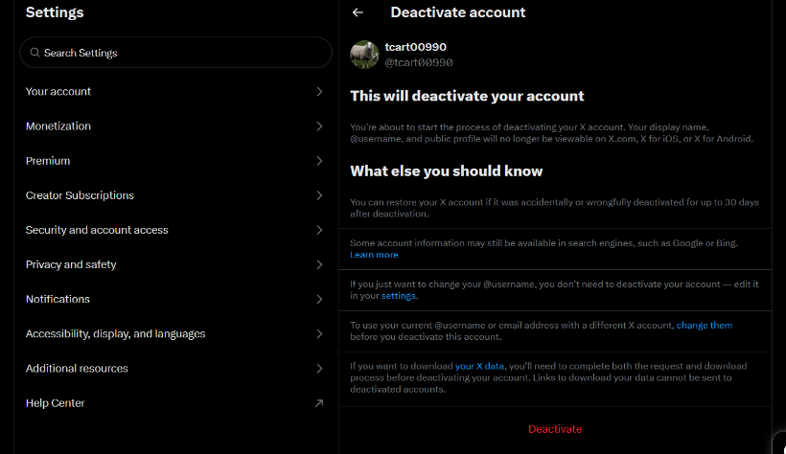  Figure 28 "Delete" account on X | 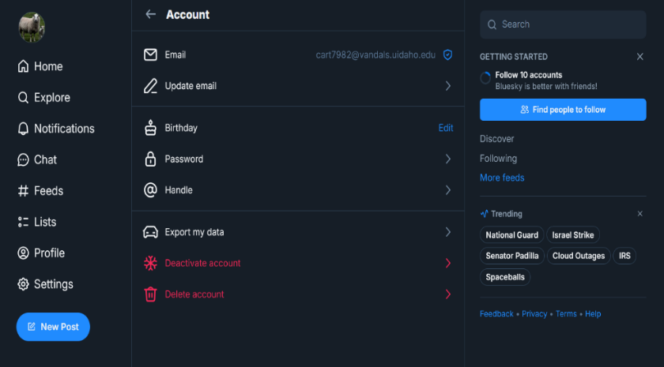  Figure 29 Delete account on Bluesky

Findings for Task 10:  Deleting an account was more straightforward on Bluesky, though that came with much greater possibility for error as there were no safeguards on deletion. Though X takes thirty days to ultimately remove the account, that grace period could help fix accidents.  On this final test, Bluesky scored a 27, and X scored a 21. | Figure 30 Results for Task 10.

Conclusion
The overall results of this comparison study into the two platforms would seem to indicate a more frequent ease of use and efficiency from the newer Bluesky over the larger and older X. Though Bluesky scored higher overall, X still proved to have a nearly equally useful and intuitive interface. Bluesky has a simpler, more direct interface that often cuts out the extra steps and additional information that X seeks out and uses, though this gives a less personal and customizable experience.  Ultimately, Bluesky scored a 249 out of 300 on the Likert scale, getting an overall higher score than X in every category.  X scored a much lower 190 out of 300, as when compared to Bluesky, it often fell short on the important details. Though it did better on blocking users and editing profiles, it fell short on all other tasks.  As this was a comparison, these tests were meant to show the contrast between the two, not necessarily their overall shortcomings.  As a recommendation by the author and going by the metrics, newcomers to both sites would generally find Bluesky to be more approachable and usable in its interfaces and overall user controls. Both platforms offer a variety of other facets, and looking strictly at usability, Bluesky is more intuitive and easier to utilize for a beginner in social media. | Figure 31 Total usability scores.  Figure 32 Total score per task. X only rises above Bluesky twice.

Bibliography

X.com
https://x.com
or
https://twitter.com

Bluesky
https://bsky.app

Appendix
Tasks | Bluesky | X (formerly Twitter)
TASK 1 | Signing up for a new account. | Signing up for a new account.
Efficient | Signing up was fast and quick. | The lack of email response and lengthy captcha meant this was inefficient.
 | Strongly Disagree Disagree Slightly Disagree Slightly Agree Agree Strongly Agree  1 2 3 4 5 6 | Strongly Disagree Disagree Slightly Disagree Slightly Agree Agree Strongly Agree  1 2 3 4 5 6
Effective | Signing up was completed quickly. | Signing up nearly failed, no email ever received.
 | Strongly Disagree Disagree Slightly Disagree Slightly Agree Agree Strongly Agree  1 2 3 4 5 6 | Strongly Disagree Disagree Slightly Disagree Slightly Agree Agree Strongly Agree  1 2 3 4 5 6
Engaging | Being moved quickly through steps kept attention. | Longer times and mandatory requirements. Ten captchas first, and then another for the phone.
 | Strongly Disagree Disagree Slightly Disagree Slightly Agree Agree Strongly Agree  1 2 3 4 5 6 | Strongly Disagree Disagree Slightly Disagree Slightly Agree Agree Strongly Agree  1 2 3 4 5 6
Error Tolerant | Seemed error resistant, even when the window was closed. | The authentication email was never sent.
 | Strongly Disagree Disagree Slightly Disagree Slightly Agree Agree Strongly Agree  1 2 3 4 5 6 | Strongly Disagree Disagree Slightly Disagree Slightly Agree Agree Strongly Agree  1 2 3 4 5 6
Easy to Learn | Guided through the steps quickly and efficiently. | The guiding process was thorough, if mandatory.
 | Strongly Disagree Disagree Slightly Disagree Slightly Agree Agree Strongly Agree  1 2 3 4 5 6 | Strongly Disagree Disagree Slightly Disagree Slightly Agree Agree Strongly Agree  1 2 3 4 5 6
Additional Notes | Signing up was fast and easy, though the system also never verified my email or checked my credentials otherwise. | Signing up was relatively arduous. The captcha took a long time, and being forced to use my phone over email was unpleasant.

Tasks | Bluesky | X (formerly Twitter)
TASK 2 | Navigate to the home page. | Navigate to the home page.
Efficient | Quick and direct. | Needed to log in first.
 | Strongly Disagree Disagree Slightly Disagree Slightly Agree Agree Strongly Agree  1 2 3 4 5 6 | Strongly Disagree Disagree Slightly Disagree Slightly Agree Agree Strongly Agree  1 2 3 4 5 6
Effective | Accomplished from anywhere. | Universal button.
 | Strongly Disagree Disagree Slightly Disagree Slightly Agree Agree Strongly Agree  1 2 3 4 5 6 | Strongly Disagree Disagree Slightly Disagree Slightly Agree Agree Strongly Agree  1 2 3 4 5 6
Engaging | Reached the goal in a single click. | Slowed down slight by logging in.
 | Strongly Disagree Disagree Slightly Disagree Slightly Agree Agree Strongly Agree  1 2 3 4 5 6 | Strongly Disagree Disagree Slightly Disagree Slightly Agree Agree Strongly Agree  1 2 3 4 5 6
Error Tolerant | The button was accessible on every page. | I was always able to return to the home page when needed.
 | Strongly Disagree Disagree Slightly Disagree Slightly Agree Agree Strongly Agree  1 2 3 4 5 6 | Strongly Disagree Disagree Slightly Disagree Slightly Agree Agree Strongly Agree  1 2 3 4 5 6
Easy to Learn | The button was clearly visible in plain bold text. | An accessible button is intuitive for any user.
 | Strongly Disagree Disagree Slightly Disagree Slightly Agree Agree Strongly Agree  1 2 3 4 5 6 | Strongly Disagree Disagree Slightly Disagree Slightly Agree Agree Strongly Agree  1 2 3 4 5 6
Additional Notes | Starting Bluesky took me directly to the home page. After navigating to other pages of the site, the home button was always available to return. | Starting X first required logging in, which then directed to the home page. Navigating away also kept the home button available.

Tasks | Bluesky | X (formerly Twitter)
TASK 3 | Create a new post. | Create a new post.
Efficient | Quick and efficient interface. First needed to verify email. | No initial popup needed. Subscription requests interfered.
 | Strongly Disagree Disagree Slightly Disagree Slightly Agree Agree Strongly Agree  1 2 3 4 5 6 | Strongly Disagree Disagree Slightly Disagree Slightly Agree Agree Strongly Agree  1 2 3 4 5 6
Effective | Simple interface accomplishes easy posting. | Extra options allows for greater control over posting.
 | Strongly Disagree Disagree Slightly Disagree Slightly Agree Agree Strongly Agree  1 2 3 4 5 6 | Strongly Disagree Disagree Slightly Disagree Slightly Agree Agree Strongly Agree  1 2 3 4 5 6
Engaging | A simpler interface is lacking in full engagement. | More features gives users more options to use. Subscription requests pushed back on engagement.
 | Strongly Disagree Disagree Slightly Disagree Slightly Agree Agree Strongly Agree  1 2 3 4 5 6 | Strongly Disagree Disagree Slightly Disagree Slightly Agree Agree Strongly Agree  1 2 3 4 5 6
Error Tolerant | The design is intuitive and difficult to break. | The AI assistant easily causes problems.
 | Strongly Disagree Disagree Slightly Disagree Slightly Agree Agree Strongly Agree  1 2 3 4 5 6 | Strongly Disagree Disagree Slightly Disagree Slightly Agree Agree Strongly Agree  1 2 3 4 5 6
Easy to Learn | Each part of the popup is quickly recognized and understood through minor exploration. | Most of the system is quickly understood through exploration, though scheduling and AI is more complex.
 | Strongly Disagree Disagree Slightly Disagree Slightly Agree Agree Strongly Agree  1 2 3 4 5 6 | Strongly Disagree Disagree Slightly Disagree Slightly Agree Agree Strongly Agree  1 2 3 4 5 6
Additional Notes | Creating a new post first required verifying email, which had not been requested until then. | Being already logged in let the post happen quick, though the popups requesting subscriptions happened frequently.

Tasks | Bluesky | X (formerly Twitter)
TASK 4 | Edit a profile. | Edit a profile.
Efficient | A simplified profile. | Much more detailed profile.
 | Strongly Disagree Disagree Slightly Disagree Slightly Agree Agree Strongly Agree  1 2 3 4 5 6 | Strongly Disagree Disagree Slightly Disagree Slightly Agree Agree Strongly Agree  1 2 3 4 5 6
Effective | Editing happens quickly, though not much control. | Complexity adds more detail and effort.
 | Strongly Disagree Disagree Slightly Disagree Slightly Agree Agree Strongly Agree  1 2 3 4 5 6 | Strongly Disagree Disagree Slightly Disagree Slightly Agree Agree Strongly Agree  1 2 3 4 5 6
Engaging | Very little to edit or add. | Many options provide a more detailed profile.
 | Strongly Disagree Disagree Slightly Disagree Slightly Agree Agree Strongly Agree  1 2 3 4 5 6 | Strongly Disagree Disagree Slightly Disagree Slightly Agree Agree Strongly Agree  1 2 3 4 5 6
Error Tolerant | So few fields are difficult to break. | More details and user control creates issues in complexity.
 | Strongly Disagree Disagree Slightly Disagree Slightly Agree Agree Strongly Agree  1 2 3 4 5 6 | Strongly Disagree Disagree Slightly Disagree Slightly Agree Agree Strongly Agree  1 2 3 4 5 6
Easy to Learn | Intuitive and self-explanatory. | The added “Professional” mode and expanded bio were additional features to understand.
 | Strongly Disagree Disagree Slightly Disagree Slightly Agree Agree Strongly Agree  1 2 3 4 5 6 | Strongly Disagree Disagree Slightly Disagree Slightly Agree Agree Strongly Agree  1 2 3 4 5 6
Additional Notes | Changing profile information was quick, as there was not much information to change. | Changing information was fairly quick as well, though the added fields and extra features weren’t as intuitive.

Tasks | Bluesky | X (formerly Twitter)
TASK 5 | Find and follow another user. | Find and follow another user.
Efficient | A button on the home page sped this up. | Finding a user required the general use search bar.
 | Strongly Disagree Disagree Slightly Disagree Slightly Agree Agree Strongly Agree  1 2 3 4 5 6 | Strongly Disagree Disagree Slightly Disagree Slightly Agree Agree Strongly Agree  1 2 3 4 5 6
Effective | Several steps were required to find a user. | Searching for a user was needed.
 | Strongly Disagree Disagree Slightly Disagree Slightly Agree Agree Strongly Agree  1 2 3 4 5 6 | Strongly Disagree Disagree Slightly Disagree Slightly Agree Agree Strongly Agree  1 2 3 4 5 6
Engaging | There is a challenge to follow ten users. | Searching for a user was not as emphasized.
 | Strongly Disagree Disagree Slightly Disagree Slightly Agree Agree Strongly Agree  1 2 3 4 5 6 | Strongly Disagree Disagree Slightly Disagree Slightly Agree Agree Strongly Agree  1 2 3 4 5 6
Error Tolerant | The introduction system may not remain present. | Following the correct account is up to the user.
 | Strongly Disagree Disagree Slightly Disagree Slightly Agree Agree Strongly Agree  1 2 3 4 5 6 | Strongly Disagree Disagree Slightly Disagree Slightly Agree Agree Strongly Agree  1 2 3 4 5 6
Easy to Learn | The button is intuitive, though other methods of following may not be. | Searching a user requires extra effort.
 | Strongly Disagree Disagree Slightly Disagree Slightly Agree Agree Strongly Agree  1 2 3 4 5 6 | Strongly Disagree Disagree Slightly Disagree Slightly Agree Agree Strongly Agree  1 2 3 4 5 6
Additional Notes | Using the suggested “Find 10 people” button was useful, though did not seem to be a standardized system. | Searching for a user presented a useful list, even if this was a relatively unintuitive process.

Tasks | Bluesky | X (formerly Twitter)
TASK 6 | Block another user. | Block another user.
Efficient | Extra steps slowed things down. | The block button was easier to reach.
 | Strongly Disagree Disagree Slightly Disagree Slightly Agree Agree Strongly Agree  1 2 3 4 5 6 | Strongly Disagree Disagree Slightly Disagree Slightly Agree Agree Strongly Agree  1 2 3 4 5 6
Effective | Blocking a user removed their posts. | Block a user prevents them from seeing your posts.
 | Strongly Disagree Disagree Slightly Disagree Slightly Agree Agree Strongly Agree  1 2 3 4 5 6 | Strongly Disagree Disagree Slightly Disagree Slightly Agree Agree Strongly Agree  1 2 3 4 5 6
Engaging | Needing to step through their profile pushes back. | Three clicks to block someone right from the main feed.
 | Strongly Disagree Disagree Slightly Disagree Slightly Agree Agree Strongly Agree  1 2 3 4 5 6 | Strongly Disagree Disagree Slightly Disagree Slightly Agree Agree Strongly Agree  1 2 3 4 5 6
Error Tolerant | Extra steps and a warning popup. | Faster and quicker means more prone to accidents.
 | Strongly Disagree Disagree Slightly Disagree Slightly Agree Agree Strongly Agree  1 2 3 4 5 6 | Strongly Disagree Disagree Slightly Disagree Slightly Agree Agree Strongly Agree  1 2 3 4 5 6
Easy to Learn | Uses standardized symbols. | Standardized symbols and less clicks.
 | Strongly Disagree Disagree Slightly Disagree Slightly Agree Agree Strongly Agree  1 2 3 4 5 6 | Strongly Disagree Disagree Slightly Disagree Slightly Agree Agree Strongly Agree  1 2 3 4 5 6
Additional Notes | Selecting the first user from the feed directed to their profile, where the block button was found. | Selecting the user from the feed allowed blocking them directly.

Tasks | Bluesky | X (formerly Twitter)
TASK 7 | Request technical assistance. | Request technical assistance.
Efficient | Quick and direct access to request system. | Could not locate live requests.
 | Strongly Disagree Disagree Slightly Disagree Slightly Agree Agree Strongly Agree  1 2 3 4 5 6 | Strongly Disagree Disagree Slightly Disagree Slightly Agree Agree Strongly Agree  1 2 3 4 5 6
Effective | Submitting the request was possible. | The Help Center consisted of very limited assistance.
 | Strongly Disagree Disagree Slightly Disagree Slightly Agree Agree Strongly Agree  1 2 3 4 5 6 | Strongly Disagree Disagree Slightly Disagree Slightly Agree Agree Strongly Agree  1 2 3 4 5 6
Engaging | Interactive response through messaging. | Reading FAQs and searching suggested articles.
 | Strongly Disagree Disagree Slightly Disagree Slightly Agree Agree Strongly Agree  1 2 3 4 5 6 | Strongly Disagree Disagree Slightly Disagree Slightly Agree Agree Strongly Agree  1 2 3 4 5 6
Error Tolerant | Relies on the user knowing what they’re talking about. | The problem may never be fixed at all.
 | Strongly Disagree Disagree Slightly Disagree Slightly Agree Agree Strongly Agree  1 2 3 4 5 6 | Strongly Disagree Disagree Slightly Disagree Slightly Agree Agree Strongly Agree  1 2 3 4 5 6
Easy to Learn | Intuitive, as Bluesky relies on asking questions. | Requires a deeper understanding of the site, and problems may still not be solved.
 | Strongly Disagree Disagree Slightly Disagree Slightly Agree Agree Strongly Agree  1 2 3 4 5 6 | Strongly Disagree Disagree Slightly Disagree Slightly Agree Agree Strongly Agree  1 2 3 4 5 6
Additional Notes | Bluesky uses a system of smaller websites, letting users directly write and send in IT requests. | X may have a system of live support but it was not found. Pages of static assistance present help and new problems both.

Tasks | Bluesky | X (formerly Twitter)
TASK 8 | Change the language settings. | Change the language settings.
Efficient | Less clicks. | More clicks.
 | Strongly Disagree Disagree Slightly Disagree Slightly Agree Agree Strongly Agree  1 2 3 4 5 6 | Strongly Disagree Disagree Slightly Disagree Slightly Agree Agree Strongly Agree  1 2 3 4 5 6
Effective | Each aspect of the site could be changed. | Less control and more emphasis on user information.
 | Strongly Disagree Disagree Slightly Disagree Slightly Agree Agree Strongly Agree  1 2 3 4 5 6 | Strongly Disagree Disagree Slightly Disagree Slightly Agree Agree Strongly Agree  1 2 3 4 5 6
Engaging | The language menu was direct. | More questions and exploration of the user.
 | Strongly Disagree Disagree Slightly Disagree Slightly Agree Agree Strongly Agree  1 2 3 4 5 6 | Strongly Disagree Disagree Slightly Disagree Slightly Agree Agree Strongly Agree  1 2 3 4 5 6
Error Tolerant | Simpler interface, but no check or way to easily revert. | More complex interface, can lead to more errors.
 | Strongly Disagree Disagree Slightly Disagree Slightly Agree Agree Strongly Agree  1 2 3 4 5 6 | Strongly Disagree Disagree Slightly Disagree Slightly Agree Agree Strongly Agree  1 2 3 4 5 6
Easy to Learn | Intuitive and easy to read. | Requires some exploration to understand features.
 | Strongly Disagree Disagree Slightly Disagree Slightly Agree Agree Strongly Agree  1 2 3 4 5 6 | Strongly Disagree Disagree Slightly Disagree Slightly Agree Agree Strongly Agree  1 2 3 4 5 6
Additional Notes | Clicking open the menu was relatively fast, and the menu was simple and effective. | Finding the system for changing the language raised some questions along the way and required more clicks.

Tasks | Bluesky | X (formerly Twitter)
TASK 9 | Change the privacy settings. | Change the privacy settings.
Efficient | The labels were less intuitive. | More blunt control using check boxes.
 | Strongly Disagree Disagree Slightly Disagree Slightly Agree Agree Strongly Agree  1 2 3 4 5 6 | Strongly Disagree Disagree Slightly Disagree Slightly Agree Agree Strongly Agree  1 2 3 4 5 6
Effective | Few options made the interface still effective. | The check marks clearly explained the situation.
 | Strongly Disagree Disagree Slightly Disagree Slightly Agree Agree Strongly Agree  1 2 3 4 5 6 | Strongly Disagree Disagree Slightly Disagree Slightly Agree Agree Strongly Agree  1 2 3 4 5 6
Engaging | The button interface worked sleekly for changing settings. | An aloof system that had to be dug through menus to find.
 | Strongly Disagree Disagree Slightly Disagree Slightly Agree Agree Strongly Agree  1 2 3 4 5 6 | Strongly Disagree Disagree Slightly Disagree Slightly Agree Agree Strongly Agree  1 2 3 4 5 6
Error Tolerant | The buttons could be easily reset. | The results of the selections weren’t always clear.
 | Strongly Disagree Disagree Slightly Disagree Slightly Agree Agree Strongly Agree  1 2 3 4 5 6 | Strongly Disagree Disagree Slightly Disagree Slightly Agree Agree Strongly Agree  1 2 3 4 5 6
Easy to Learn | Simple, colorful interface with animated buttons. | Menus with relatively detailed explanations.
 | Strongly Disagree Disagree Slightly Disagree Slightly Agree Agree Strongly Agree  1 2 3 4 5 6 | Strongly Disagree Disagree Slightly Disagree Slightly Agree Agree Strongly Agree  1 2 3 4 5 6
Additional Notes | Changing the privacy settings was quick, though somewhat unintuitive to find in comparison. | Finding the privacy settings was easy, though

Tasks | Bluesky | X (formerly Twitter)
TASK 10 | Delete an account. | Delete an account.
Efficient | Very quick and easy to delete account. | Interface was easy to use and had all needed information.
 | Strongly Disagree Disagree Slightly Disagree Slightly Agree Agree Strongly Agree  1 2 3 4 5 6 | Strongly Disagree Disagree Slightly Disagree Slightly Agree Agree Strongly Agree  1 2 3 4 5 6
Effective | Account immediately deleted. | No way to outright delete an account.
 | Strongly Disagree Disagree Slightly Disagree Slightly Agree Agree Strongly Agree  1 2 3 4 5 6 | Strongly Disagree Disagree Slightly Disagree Slightly Agree Agree Strongly Agree  1 2 3 4 5 6
Engaging | Each step was easy to use and explained well. | The descriptions were present, if not as clear.
 | Strongly Disagree Disagree Slightly Disagree Slightly Agree Agree Strongly Agree  1 2 3 4 5 6 | Strongly Disagree Disagree Slightly Disagree Slightly Agree Agree Strongly Agree  1 2 3 4 5 6
Error Tolerant | Deletion is very final, though there are several layers of confirmation. | Though inconvenient otherwise, the thirty day grace period gives ample time to recover an account.
 | Strongly Disagree Disagree Slightly Disagree Slightly Agree Agree Strongly Agree  1 2 3 4 5 6 | Strongly Disagree Disagree Slightly Disagree Slightly Agree Agree Strongly Agree  1 2 3 4 5 6
Easy to Learn | Clear prompts on screen. | Process is explained along the way, though a thirty day window is still surprising.
 | Strongly Disagree Disagree Slightly Disagree Slightly Agree Agree Strongly Agree  1 2 3 4 5 6 | Strongly Disagree Disagree Slightly Disagree Slightly Agree Agree Strongly Agree  1 2 3 4 5 6
Additional Notes | After working through the menus, the password for the account was inputted in a popup and a confirmation email was sent with a verification code. | Requesting deactivation required no further verification, though there were several warnings about the thirty-day grace period.

